**GUI Project**

Name: William Wang

Date: November 1st 2019

Description:

My application features a minimalistic but appealing graphic user interface with options to add, edit, save or import passwords and account information that emphasizes a user's ease of access and simplicity.

Justification for the Proposed Project:

This GUI Project is my solution to my client, who proposed for a password manager that is offline and practical. Despite alternatives such as Google’s automatic password logger and other online services, my client wants to have peace of mind by having the passwords saved offline as opposed to the cloud. The alternatives available online require an internet connection as well as having to log in and is too complex for my client’s needs, with many charging a monthly subscription service and requiring users to agree to lengthy Terms of Service.

The main reason I chose to program in Java is that my client’s home computer uses Windows while their company’s computers run Mac. Java’s advantage of being platform-independent greatly swayed my decision as it will allow my application to be portable on a USB and run on whatever operating system my client happens to use. Java is also object-oriented, which supports reusable code such as my Account and User classes and a more flexible system. Due to the modular nature of Java, one can update specific parts of the system without needing to restructure the entire system, allowing for faster development as well as easier maintenance and debugging.

(Word Count: 199)

UML Diagram: (The List of Fields and Method does not fit, so I have attached the list below the diagram for every class)

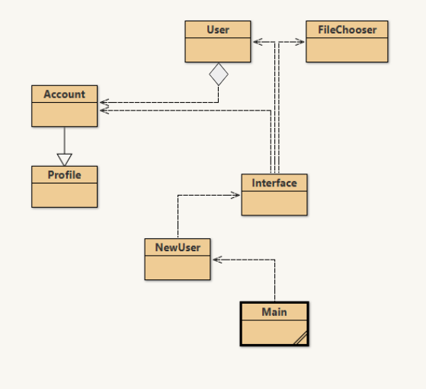

File Chooser:

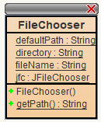

User:

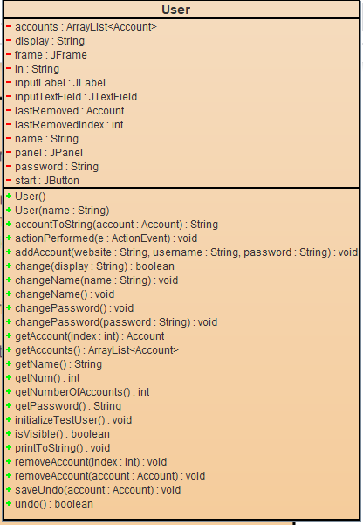

Interface:

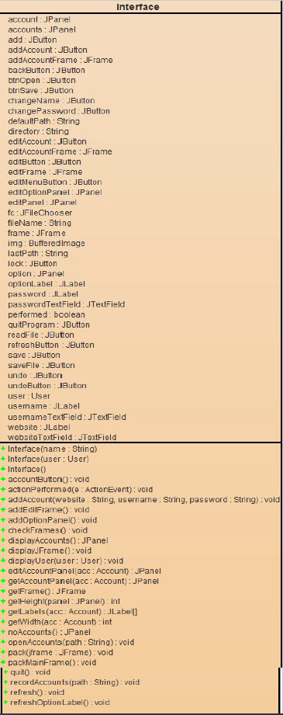

Account:

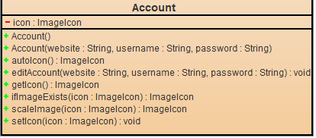

Profile:

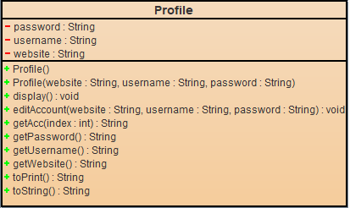

NewUser:

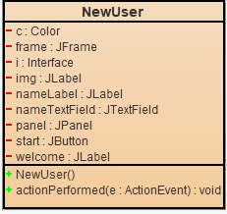

Main:

